Shri Ramdeobaba College of Engineering and Management

Department of Mechanical Engineering, RCOEM Nagpur

**Robotic and Aviation Club**

**ANNEXURE I**

**INDEX**

1.1 About the club………………………………………………………………..3

1.2 Objective ………….…………………………………………………………3

1.3 The Context…………………………………………………………………..3

1.4 Evidence of success………………………………………………………......4

1.5 Past achievements and participation………………………………………….5

*1.5.1 Drone and aviation domain*

*1.5.2 Robotics Domain*

*1.5.3 Details of participation for current year*

1.5.4 List of second year members who participated

1.6 Events and Activities Conducted……………………………………………..8

*1.6.1 Details*

1.6.1.1 Robothon

1.6.1.2 Recruitment

1.6.1.3 Task Phase

1.6.1.4 Drone Workshop

1.7 Proposed Events and Activities………………………………………………12

*1.7.1 Details*

1.7.1.1 Robo-mela

1.7.1.2 Making of 15 RC Planes

1.7.1.3 Club Website launch

1.7.1.4 Courses offered

1.7.1.5 Designing custom frame for Drones

1.7.1.6 Inter College Robotics Competition

1.7.1.8 Testing of custom frames for Drones

1.8 Target National Competitions………………………………………………..19

1.9 Softwares and technologies that will be taught to students for these

Competitions ……………………………………………………………………..19

2.0 List of members in Robotics and Aviation Club……………………………..20

Shri Ramdeobaba College of Engineering and Management

Department of Mechanical Engineering, RCOEM, Nagpur

**Robotics and Aviation Club**

**1.1 About the Club:**

The Robotics Club (RCOEM) was established in 2014 with the primary objective of providing a shared platform for students from diverse disciplines to explore the fascinating field of robotics. The club aims to foster a creative environment that encourages innovation, imagination, and the exchange of knowledge among aspiring technocrats.

Since its inception, the club has actively participated in numerous events and competitions across the country. Some of the prominent competitions include Techfest (IIT Bombay), Techniche (IIT Guwahati), E-yantra, AXIS (VNIT), Atmos (BITS), ROBOCON, and various local events. In addition, the club has organized its own robotic events such as Robothon and conducted workshops on cutting-edge subjects like Artificial Intelligence, Brainwave Controlled Bot, and Gesture Control Bot. Furthermore, guest lectures have been organized to promote the culture of robotics within the college.

Through its dynamic initiatives and dedicated efforts, the Robotics Club at RCOEM continues to inspire and empower students, cultivating a vibrant and forward-thinking community of technologically-driven individuals.

**1.2 Objectives:**

The Robotics Club at RCOEM was established with a fundamental objective of creating a unified platform for students from diverse disciplines to gain exposure to the exciting field of robotics. By encouraging active participation in various robotics competitions and activities, the club aims to provide students with invaluable hands-on experience. Additionally, the club fosters a creative environment that nurtures innovation, imagination, and the exchange of wisdom and experience among aspiring technocrats. Through practical and experiential learning opportunities, the club ensures that students not only acquire theoretical knowledge but also develop the practical skills required in the field of robotics.

**1.3 The Context :**

Established in 2014, the Robotics Club at RCOEM serves as a unifying platform for students from diverse disciplines to engage with robotics. With a focus on fostering a creative environment that nurtures innovation, imagination, and the exchange of wisdom and experience, the club provides an ideal space for aspiring technocrats to thrive. Offering hands-on training, technical skill development, and capacity building, the Robotics Club empowers students to acquire practical expertise in the field of robotics.

**1.4 Evidence of Success :**

The club has been very active in various technical events conducted throughout the year in the college as well as in NIT’s, IIIT’s and IIT’s We currently have over 50 students in the club and equal opportunities are provided to each club member.

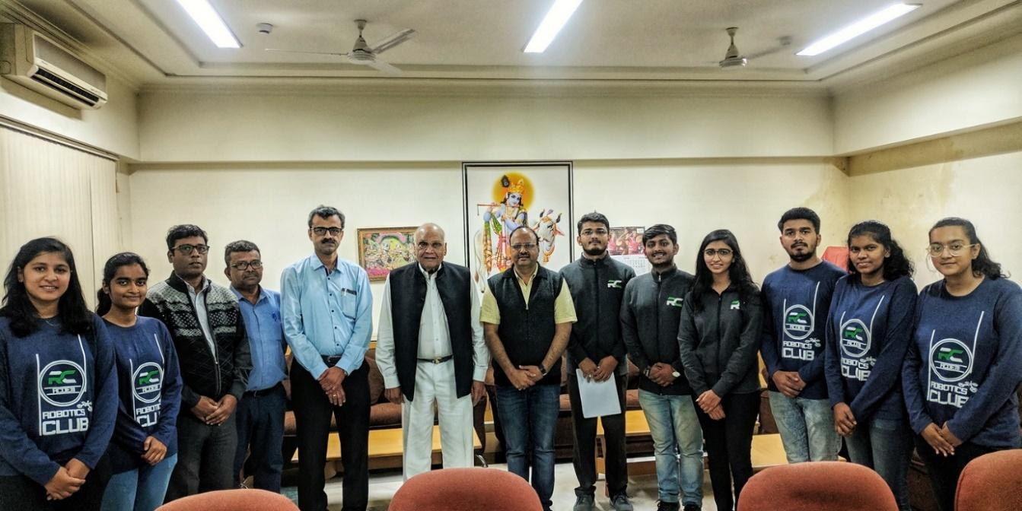

***Figure 1.4.1 :******Team Marcos****- Robotics Club of RCOEM with Shri G. L. Agrawal, General Secretary and Dr. R. S. Pande, Principal on clearing first round (Virtuals) of the DD-National* ***Robocon 2020****.*

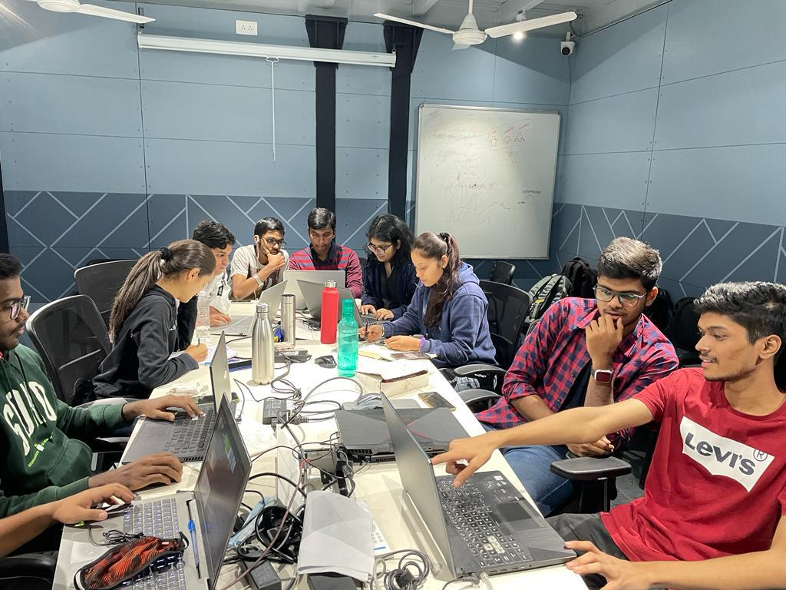



***Figure 1.4.2 :******Team Parker*** *secured* ***17th*** *position amongst teams overall the world in Phase I of* ***Abu-ROBOCON 2022 scoring 98/100*.**

After the determinant efforts of the team, we had received sponsorship (in kind) worth Rs.2,84,40,000/- in the form of License of various software as follows: -

40 — Solidworks (Rs.2,83,000/- each) for a period of 2 years

25 — Hyperworks (Rs.3,90,000/- each) for a period of 1 years

21 — Mathworks (Rs.2,20,000/- each) for a period of 1 years

05 — ANSYS (Rs.5,50,000/-) for a period of 1 years

**1.5 Past achievements and participation :**

***1.5.1 Drone and Aviation domain:***

**Total Races :** 3

**Total points :** 15

| Sr No : | Competition | Organizing Institute | Year |
| --- | --- | --- | --- |
| 1 | IDRL S7Ep9 @ APOGEE | BITS Pilani | 2023 |
| 2 | IDRL S7Ep8 @ Technex-23 | SPVCET | 2023 |
| 3 | IDRL S7Ep6 @ Amalthea | IIT Gandhinagar | 2022 |

***Table 1.5.1.1: Drone and Aviation achievements***

***1.5.2 Robotics Domain :***

| **Sr No.** | **Date/Year** | **Organizing Institute** | **Event** | **No. of Teams** | **Details** |
| --- | --- | --- | --- | --- | --- |
| 1 | 7th-9th Jan 2023 | VNIT Nagpur | AXIS'23 | | |
| Manual Robotics | 3 | Participation |
| Robowars | 1 | Participation |
| 2 | 16th - 18th Dec 2022 | IIT Bombay | Meshmerize (Techfest) | 6 | 6 Teams participated in the zonals held. |
| 3 | 2022 | IIT Bombay | E yantra | 4 | 4 teams participated and are competing in round 1. |
| 4 | 2020 | IIT Bombay | E yantra | 5 | 2 teams got selected for the 1st round. |
| 5 | 2019 | IIT Bombay | E yantra | 26 | 21 teams got selected for 2nd round |
| **Sr No.** | **Date/Year** | **Organizing Institute** | **Event** | **No. of Teams** | **Details** |
| 6 | 2019 | IIT Bombay | Techfest | | |
| Meshmerize | 7 | Participation |
| Cosmo Clench | 5 | 3 teams secured top 10 positions |
| 7 | 2019 | IIIT Nagpur | Line follower (TantraFiesta) | 5 | 1st position |
| 8 | 2019 | GCOE Nagpur | Adhyaaya | | |
| Robo soccer | 2 | Participation |
| Ravic (Breadboard maze) | 5 | 1st position |
| Avishkar | 3 | 1team got selected for semifinals |
| 9 | 2019 | VNIT Nagpur | AXIS'19 | | |
| Line Following | 3 | 1 team secured 2nd position |
| Manual Robotics | 3 | 1 team secured 2nd position |
| Aqua skylark | 2 | Participation |
| Robo-olympia | 3 | Participation |
| 10 | 2018 | IIT Bombay | Meshmerize (Techfest) | 6 | 2 teams got selected for Finals and also secured top 10 position in Techfest 2018 |
| 11 | 2018 | IIT Bombay | E yantra 2018 | 15 | 1 team got selected for the final round and 3 teams qualified 2nd task |
| 12 | 2017 | IIT BOMBAY | International Robotics Challenge | 2 | 1 teams got selected for semifinals |

***Table 1.5.2.1: Robotics Domain Achievements***

***1.5.3 Details of participation for the session 2022-23 :***

**Our teams in AXIS’23 at VNIT Nagpur :**

1. **Cosmo clench :-**

Three teams from our club went to AXIS – VNIT for Cosmo clench. Every second year of the club participated in the event in either cosmoclench or Robowars. In total we made 4 robots, 3 cosmoclench and 1 Robowars. This was the first competition for the newly recruited batch and the performed extremely well while working tirelessly day in and out.

1. **Robowars :-**

With outmost dedication we were successfully able to design a line follower robot under 8 kg category for Robowars held under AXIS’23 by VNIT nagpur. We proved to be the **only Robowars Team of Nagpur** competing with teams from various other cities like Bhopal , Amritsar etc.

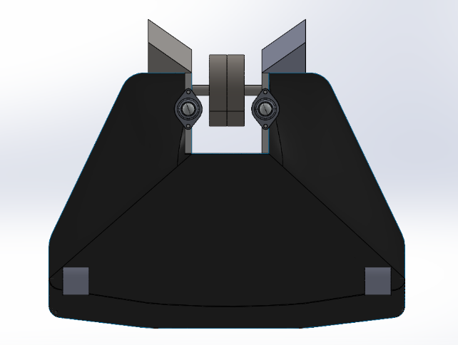

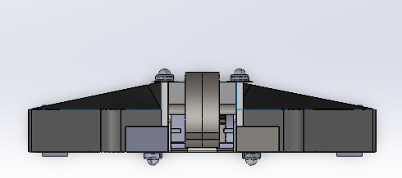



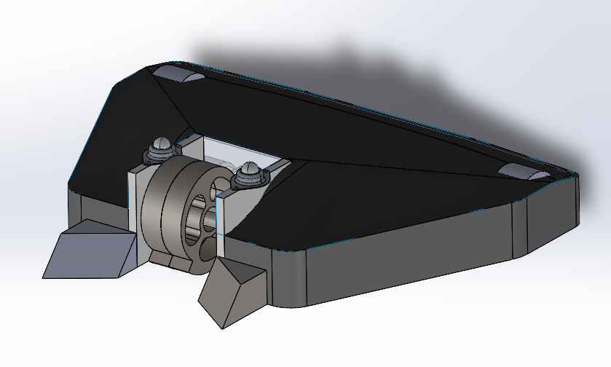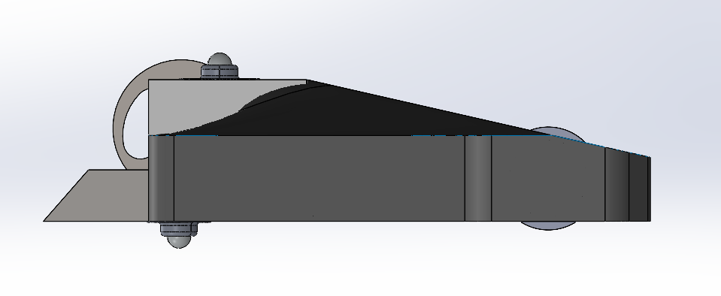



**1.5.4 List of second year members who participated in AXIS VNIT:**

| Team No | Member 1 | Member 2 | Member 3 | Member 4 | Competition |
| --- | --- | --- | --- | --- | --- |
| 1 | Gaurav Bankar | Shashwat Mishra | Bhavesh Gupta | Kaif Raza | Robowars |
| 2 | Kartikeyan Venkatesh | Vedant Pinjarkar | Ved Jaiswal | __ | Cozmo clench |
| 3 | Harshita Soni | Etisha Shastri | Kaif Raza | __ | Cozmo clench |
| 4 | Nikhil Kakde | Sahil Nimbalkar | Kaustubh Ghatbandhe | __ | Cozmo clench |

*Table 1.5.4.1: List of 2nd year students that participated in AXIS VNIT*

**1.6 Events and Activities Conducted:**

| **Sr. No.** | **Dates** | **Event / Activity** | **Scope** |
| --- | --- | --- | --- |
| 1 | June 2022 | Robothon | Intra College |
| 2 | Jan 2023 | Recruitment | Club members |
| 3 | Jan - Feb 2023 | Task Phase | Club members |
| 4 | Jan - Feb 2023 | Drone Workshop Conducted | Club members |

*Table 1.6. 1: Evemts and Achievements*

**e-Yantra Robotics Competition:**

e-Yantra is a robotics-focused educational outreach initiative of the Department of Computer Science and Engineering at the Indian Institute of Technology, Bombay.

1. **Cosmo Logistics**

The eYRC 2023-24 theme, "Cosmo Logistic," featured inter-planet logistics in a space station warehouse. Teams created algorithms for autonomous package sorting using a robotic arm and mobile robot. Using SLAM, they navigated the robot in a simulator (Gazebo) in stage 1 and later remotely controlled real hardware in a warehouse at IIT Bombay in stage 2.

1. **Geo Guide**

The eYRC 2023-24 introduced "GeoGuide," featuring the robotic vehicle "Vanguard" guided by a static drone named Watchtower. Equipped with machine learning algorithms, Watchtower aids Vanguard in navigating a dynamic arena, avoiding danger zones, and responding to alien attacks. The theme focused on creating an autonomous robot using an overhead camera for guidance, with students utilizing the ESP32 microcontroller to delve into image processing and machine learning.

1. **Astro Tinker Bot**

The eYRC 2023-24 theme "AstroTinker (AT) Bot," is where we built a robot using an FPGA as its powerhouse. The robot, receiving wireless alerts, navigates a space station's modules to identify and communicate component issues to a central hub. The challenge involved creating a CPU architecture using Verilog HDL, showcasing FPGA's parallel processing capabilities.

1. **Luminosity Drone**

As the Luminosity Drone explored an alien landscape, it detected a mysterious heat signature from a nearby cave. Following the signals, it discovered a hidden ecosystem with diverse life forms. Continuing its mission on other planets, the drone expanded humanity's understanding of the universe, forever changing our perception of extraterrestrial life.

**List of members who participated in e-Yantra Robotics Competition:**

| Team No | Member 1 | Member 2 | Member 3 | Member 4 | Competition |
| --- | --- | --- | --- | --- | --- |
| 1 | Pankaj Kumar Singh | Nikhil Kakde | Sarah Farooqui | Smeet Shelke | Cosmo logistic |
| 2 | Ved Jaiswal | Samyak Tundurwar | Kartikeyan Venkatesh | Advait Deshmukh | Cosmo logistic |
| 3 | Sahil Nimburkar | Divyansh Pandey | Kaustubh Ghatbandhe | Ansh Shahu | Cosmo logistic |
| 4 | Etisha shastri | Priyanshu kisan | Anirudh lakha | Aadya Pande | Cosmo logistic |
| 5 | Shashwat Mishra | Satyam Mishra | Varad Bodkhe | Parth Rambhale | GeoGuide |
| 6 | Yagyesh Bobde | Samruddhi Ambatkar | Tejas Gangane | Aakhyan Jeyush | GeoGuide |
| 7 | Nishang Lingalwar | Anshika Gupta | Archeta Sugandh | Mohammed Rushaad Qureshi | GeoGuide |
| 8 | Anushree Jain | Isha Chaudhari | Ojas Berdia | Kunal Mohare | GeoGuide |
| 9 | Harshita Soni | Vedant Pinjarkar | Siddhi Sahu | Anish Ghosh | AstroTinker Bot |
| 10 | Gaurav Bankar | Tanuj Kewalramani | Rohan Dhote | Kshitij Lambat | Luminosity Drone |
| 11 | Arnav Tijare | Burhanuddin Saify | Abhishree Kolharkar | Pranay Pawar | Luminosity Drone |
| 12 | Mohammad Kaif Raza Kalim Ansari | Sushant Balkrushna There | Praveen Agrawal | Jai Hirasinghani | Luminosity Drone |

**Our teams in Technoxian 7.0 at World Robotics Championship, Delhi:**

1. **Fastest Line Follower:**

We build our own autonomous robot within the specified dimensions to achieve the maximum speed on the given track and reach the destination in minimum time. The task was to follow the black line. The competition area has a special place defined for the robot’s operation.

1. **RC Craft:**

We Build RC Planes which are aerodynamically sound and within the specified dimensions to achieve a successful flight. The RC plane should be able to take off, land, and can-do maneuver. The competition has 3 Rounds i.e., two elimination rounds and the final round. The performance of the RC Plane in all the Rounds/Arenas will be evaluated individually. The team Scoring the maximum points in the final round will be nominated as the winner of the competition.

1. **Drone Challenge:**

Here at Technoxian Drone Challenge, we build drone within the specified dimensions that are aerodynamically stable to achieve a successful flight. The competition has 4 rounds, in which the performance of the drone will be evaluated individually. The team Scoring the maximum points in the final round will be nominated as the winner of the competition.

1. **Robo Race:**

In this challenge we build your own wireless bot within the specified dimensions in order to achieve the maximum speed to beat other bots on the given track and reach the finishing line in minimum time.

**List of members who participated in Technoxian World Robotics Competition:**

| **Team Name** | **Silver Wings** | **Sci-Fy** | **Wind Warriors** | **Flying Bulls** |
| --- | --- | --- | --- | --- |
| **Competition** | **Rc Craft , Robo Race** | **RC Craft, Fastest Line follower** | **RC plane, Drone Challenge** | **RC Craft, Drone Challenge** |
| **Team Leader** | Mohammad Rushaad Qureshi | Gaurav Bankar | Tanuj Kevalramani | Anushree Jain |
| **Co-pilot** | Bhavesh Gupta | Pankaj Kumar Singh | Sahil Nimburkar | Divyansh Pandey |
| **Members** | Ved Jaiswal | Anish Ghosh | Siddhi Sahu | Pratik Agrawal |
| Harshita Soni | Yagyesh Bobde | Jay Hirasinghani | Manaswini Verma |
| Mohammad Kaif Raza Kalim Ansari | Tejas Gangane | Sushant There | Aniruddh Lakha |
| Nikhil Kakde | Satyam Mishra | Mayank Rai | Archita Sugandh |
| Vedant Pinjarkar | Kaustubh Ghatbandhe | Ansh Shahu | Nishang Lingalwar |
| Shantanu Mane | Anshika Gupta | Samruddhi Ambatkar | Sarah Farooqui |
| Kartikeyan Venkatesh | Aadya Pande | Etisha Shastri | Aaditya Chaturmohta |
| Samyak Tundurwar | Shaswat Mishra | Varad Bodkhe | Advait Deshmukh |

**Our Achievements in Technoxian:**

* Our team Flying Bulls has emerged victorious in the RC Craft Challenge at Technoxian World Robotic Championship.
* Team Sci-fy qualified for the final round of Fastest line follower.

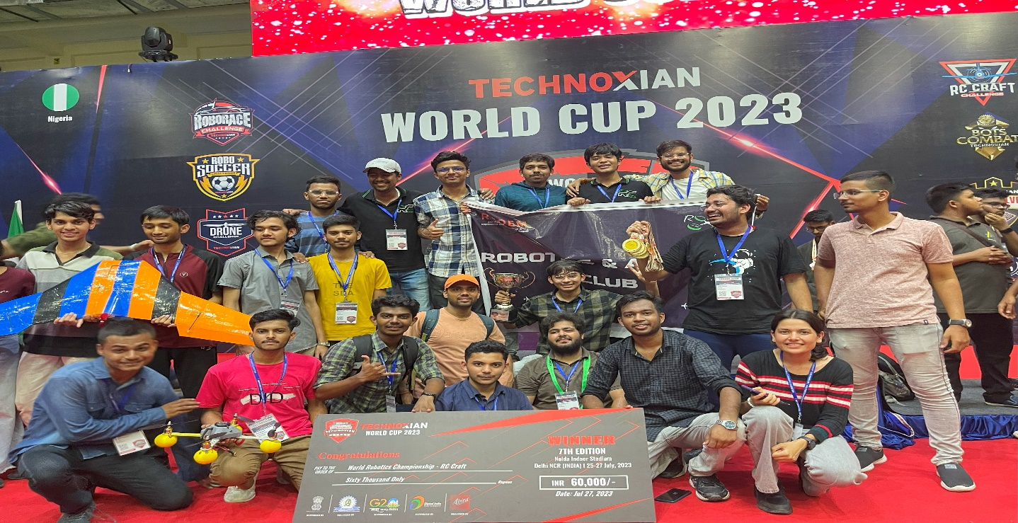

*Figure 1 Our Winning team at Technoxian 7.0*

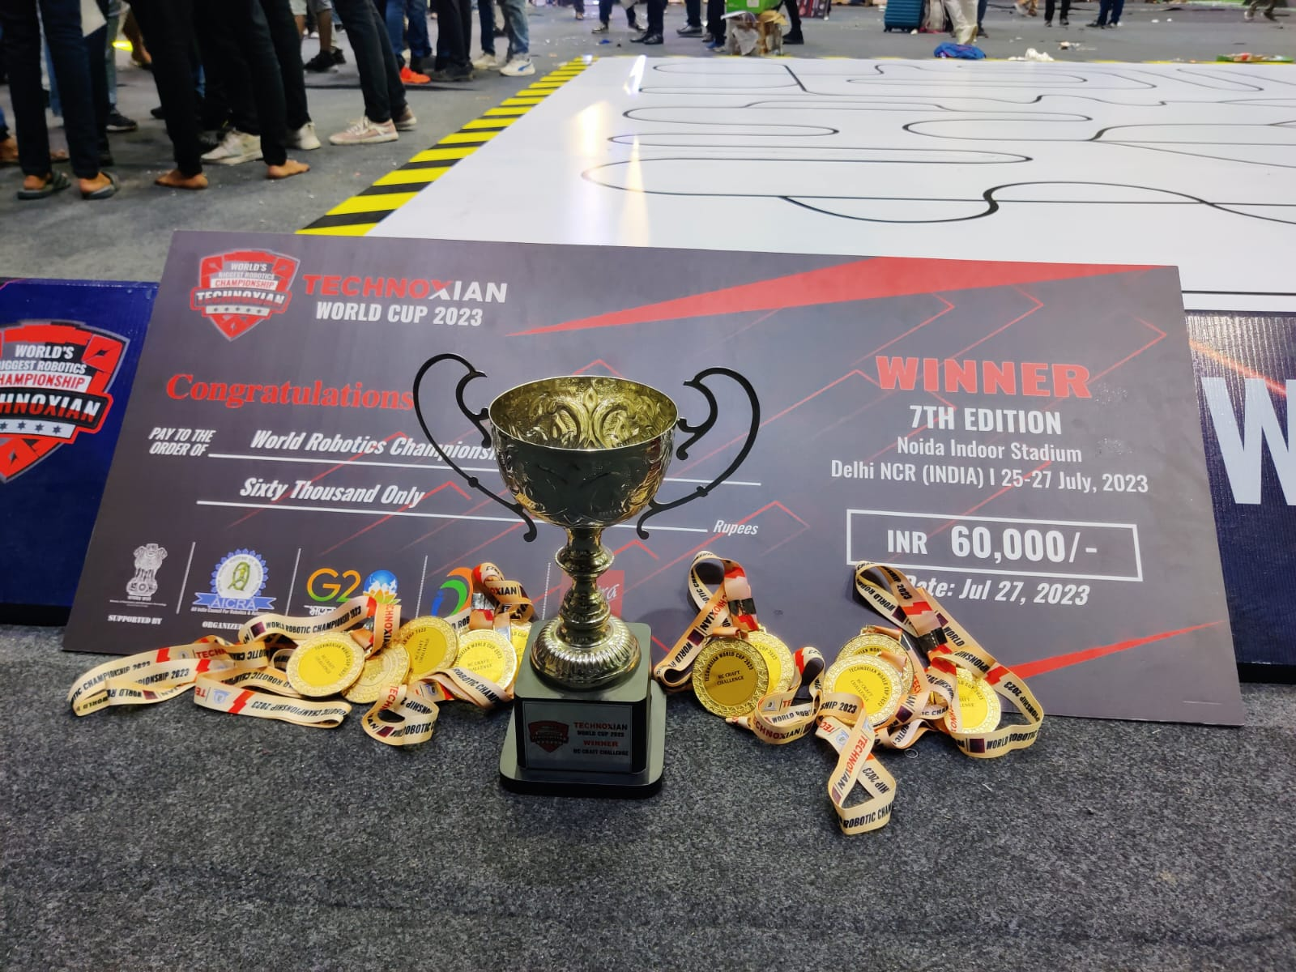

*Figure 2 Winning Trophy*

***1.6.1 Details:-***

**1.6.1.1 Robothon :-**

**ROBOTHON 22,** a three-phased 15 days (about 2 weeks) long event conducted for freshers (first years), where they were oriented about *arduino* and its interfacing with various components and constructing a line follower bot.

Phase 1: A 2-days interactive workshop, where club members oriented the students regarding arduino, coding for arduino on tinker-cad and interfacing motors, moto drivers and sensor arrays to it. It witnessed 275 participants. A quiz was conducted at the end of the session, 45 teams out of 75 were shortlisted.

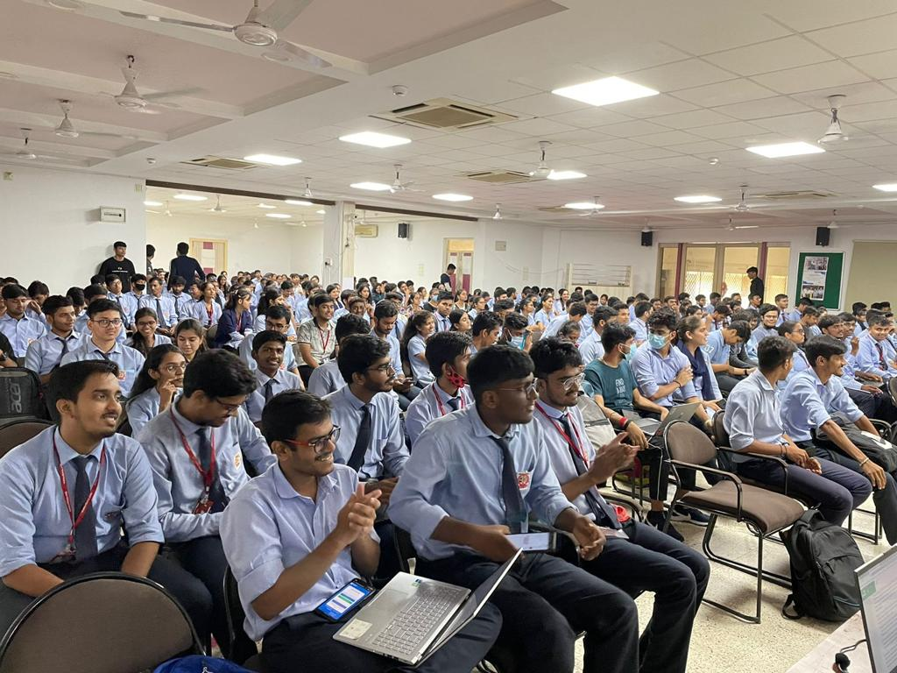

*Figure 1.6.1.1. 1: Students in Phase-1 (Workshop)*

*Phase 2:* Documentation Phase, in this phase the participants were asked to submit a detailed documentation for the design of Line-follower bot they would present at the Phase 3 Hands on – Robothon , for which 7 teams were shortlisted.

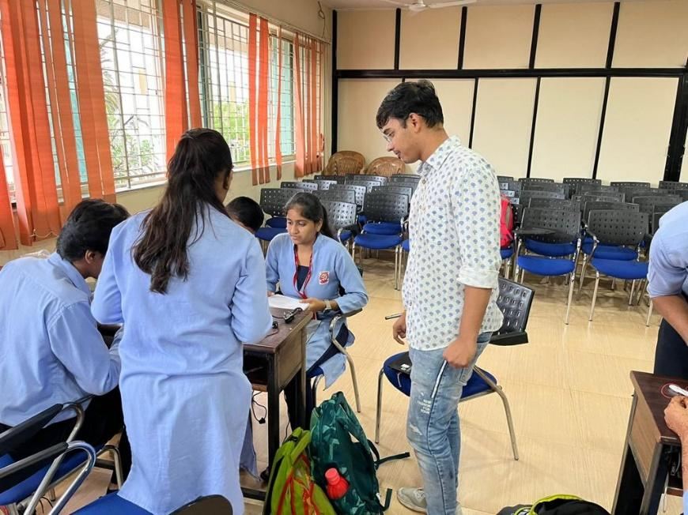

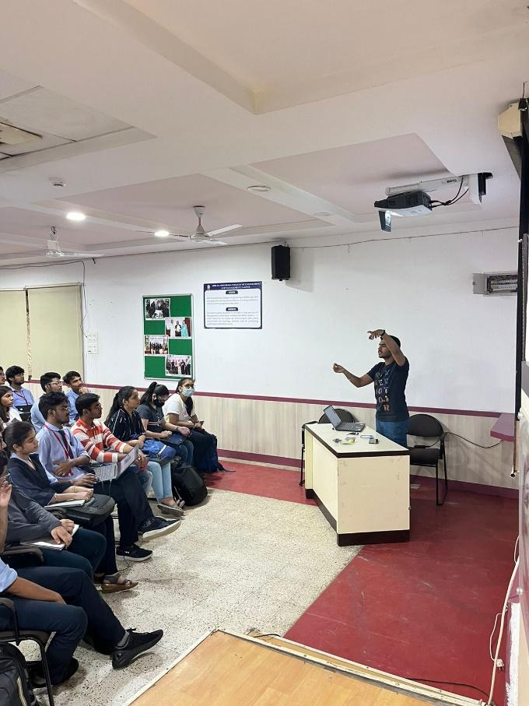

*Phase 3*: A three-hour hackathon where the teams were expected to build a Line follower bot and the one successfully completing the traversal of track won.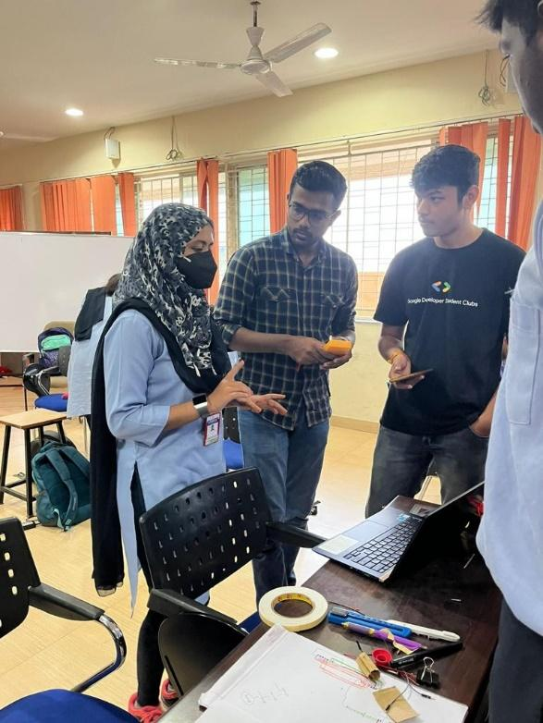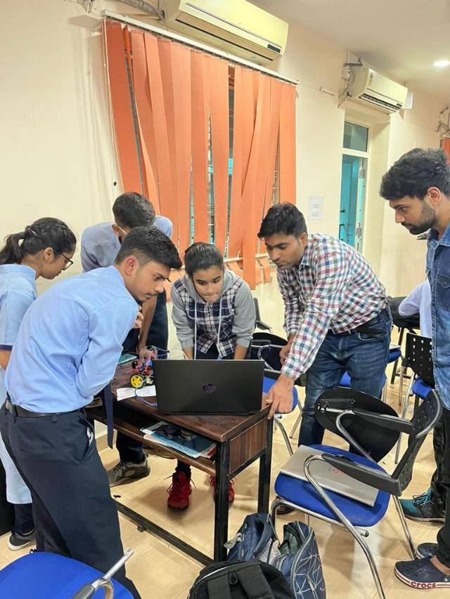

**1.6.1.2 Recruitment :-**

The club has recruited 22 students after a two phased recruitment process on 8th January 2023 that included aptitude test and a personal interview. The selected students constitute of 14 - 2nd years and 8 – 1st years.

**1.6.1.3 Task Phase :-**

The objective of this session was to make sure every student in the club knows how to design, assemble as well as code a robot all by themselves. During the orientation phase, the students also introduced to basic Robotics which included hands on sessions on:

1. *Computer-Aided Design (CAD) modelling* :

The aim was to make students capable enough to design their own models and test them as well. We taught the students how to use two important softwares in designing, **SolidWorks** and **Fusion 360.** In a week long training session they were taught the useful commands like sketching, extruding, cutting etc. but most importantly we taught them how to think like an engineer while designing. An emphasis was given on designing keeping the manufacturability in mind.

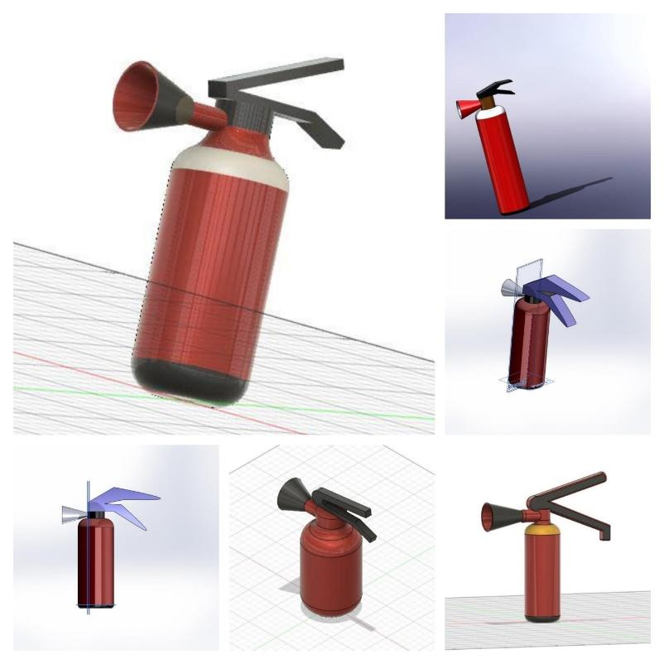

*Figure 1.6.1.3.1: 3D Models prepared during the workshop on CAD.*

1. *Fundamentals of electronics:*

The objective of this session was to equip students with the required skills to make their first line follower. It started with the very basics by introducing them to the underlying physics of the hardware and how these small components help them to perform logical tasks. At the end of the course they were capable of making a line follower all by themselves using Arduino Uno R3, L298N motor driver and other components.

1. *Programming in python from basic to intermediate level:*

This course included sessions on how a python code works, the computer architecture and environment required, various components of code like datatypes, operators, control flow, data structures, functions, modules and packages.

The second track of the same constituted, briefing students about important libraries such as Numpy, Pandas, Matplotlib and a rigorous session on exploratory data analysis which will help students to strengthen their foundation for automation.

**1.6.1.4 Drone Workshop :-**

The Drone Workshop conducted by the Flying Club provided participants with hands-on experience and knowledge about drones, their applications, and safe flying practices. The workshop covered drone types, components, operation, and explored the potential of unmanned aerial vehicles (UAVs).

**1.7 Proposed Events and Activities :**

| Sr. No. | Tentative Dates | Work duration | Event / Activity | Scope |
| --- | --- | --- | --- | --- |
| 1 | 22nd June 2023 | May - June 23 | Robo-Mela | Intra College |
| 2 | last week of June 2023 | May - June 23 | Making of 15 RC Planes | Club members |
| 3 | last week of July 2023 | May - July 23 | Club Website Launch | Club members |
| 4 | last week of October 2023 | July - October 23 | Designing custom frame for Drones | Club members |
| 5 | last week of November 2023 | August - November 23 | Inter College Robotics Competition | Inter College |
| 6 | first week of December 2023 | –- | Testing of custom frames for Drones | Club members |

*Table 1.7.1: Proposed Events Timeline*

***1.7.1 Details:***

**1.7.1.1 Robo-mela :**

Robo-Mela is RCOEM’s biggest robotics carnival full of eye catching toys and trinkets that attract the attention of people from various disciplines. It is organized by the Robotics and Aviation Club of RCOEM and is a spectacular sight which invites people into the world of robotics and aviation. It features some of the coolest projects on campus which are bound to draw a crowd over the event.

* **Udan Tashtari**

The participant will have to perform maneuvers on a drone around a bunch of obstacles and will have to fly through some hoops to win. This game is a nail-biting time trial.

* **RC Monster Truck**

We will make a monster truck themed bot which the participant will have to use to overcome all the obstacles in his path on his way to victory. This game will give the participant the full experience of the Monster truck carnage .

* **Khwabo Ki Kashti**

Two participants will navigate the treacherous waters through our boats with an accomplice by their side and whoever comes out on top will take away the prize.

* **Cozmobot**

The participant has to overcome all the obstacles and challenges to survive on the difficult terrain of mars. We will provide our bot and the participants has to perform all the tasks and overcome the challenging track.

The Robotics Mela of Robotics and Aviation Club RCOEM is a sight to behold for one and all from 22nd and 23rd of June 2023.

**1.7.1.2 Making of 15 RC Planes :**

The process of making RC planes will greatly benefit the club in preparing for competitions throughout the year. Here's an elaboration on how this activity will be advantageous:

* ***Technical Skills Development:***

Building 15 RC planes requires the club members to work on various aspects of aircraft construction, such as assembling the frame, installing motors and servos, wiring electronic components, and configuring flight control systems. This hands-on experience helps club members enhance their technical skills in areas like aerodynamics, electronics, and mechanical assembly, which are essential for success in drone competitions.

* ***Understanding Flight Dynamics:***

By constructing RC planes, club members gain a deep understanding of the principles of flight dynamics. They learn about wing design, control surfaces, center of gravity, and how different factors affect an aircraft's stability and maneuverability. This knowledge becomes invaluable when designing and piloting drones, as it allows club members to optimize their aircraft's performance for specific competition challenges.

* ***Flight Testing and Optimization:***

As the club members build and assemble the RC planes, they will conduct flight tests to assess their performance. This process involves adjusting control surfaces, tuning motor thrust, and balancing the aircraft for optimal flight characteristics. Through experimentation and iterative improvements, the club members will fine-tune the planes' performance, ensuring that they can meet the specific requirements of different competition tasks.

* ***Pilot Training:***

Alongside constructing the RC planes, the club members will use them as training platforms for aspiring drone pilots. Flying RC planes helps improve manual dexterity, spatial awareness, and hand-eye coordination—essential skills for successfully piloting drones. The club will organize regular flying sessions, allowing members to practice their piloting skills, refine their maneuvers, and gain confidence in controlling aerial vehicles.

* ***Teamwork and Collaboration:***

The process of building 15 RC planes will be a collaborative effort, encouraging teamwork within the club. Club members will work together in pairs or small groups to assemble the planes, troubleshoot technical issues, and share knowledge and expertise. This collaborative environment promotes effective communication, problem-solving, and resource sharing, all of which are essential for success in competitions that require teamwork.

* ***Competition Simulation:***

Once the RC planes are ready, the club will organize inter-college competitions and participate in competitions organized by other colleges to simulate the challenges they might face in international drone competitions like **Aerothon**. These simulated events provide valuable opportunities for members to test their skills, develop strategies, and evaluate their aircraft's performance under competitive conditions. It allows them to identify areas of improvement and make necessary adjustments before participating in external competitions.

* ***Knowledge Transfer:***

The experience gained from building and flying RC planes will be shared within the club. Members will document their learnings, capture best practices, and create instructional materials or workshops to educate newer members. This knowledge transfer ensures that the club's collective expertise continues to grow, empowering future generations of club members to excel in robotics and drone competitions.

This process of making 15 RC planes offers numerous benefits to the club. It enables the development of technical skills, enhances understanding of flight dynamics, provides a platform for flight testing and optimization, offers pilot training opportunities, fosters teamwork and collaboration, facilitates competition simulation, and promotes knowledge transfer. These advantages collectively prepare the club members for a successful participation in various competitions throughout the year.

**1.7.1.3 Club Website launch :**

The club is excited to announce the launch of its website, which will serve as a comprehensive platform for all activities and events conducted by the club. Visitors to the website will be able to view updates on the club's participation and achievements in various inter-college, national, and international competitions. Additionally, the website will showcase the club's rich alumni network, provide information on members, student committees, and faculty in charge.

The website will also serve as a central hub for promoting and hosting future events and collaborations with other colleges. To further our commitment to robotics education, the club will offer rigorous courses on the basics of Robotics and Aviation, Line Follower, Cozmo Clench Bot-design tutorials, and Robotics Operating System (ROS). These courses will be accessible to every student in the college, free of charge. By offering these incentive courses, the club becomes **the first in college history** to provide cutting-edge resources to help students stay up to date with the latest technological developments.

Through the website, technical enthusiasts can explore and learn more about robotics and aviation. Our goal is to cultivate a strong robotics culture within the college and provide resources that will benefit all students interested in this field. The courses will include assessments and tutorials, and upon completion, students will receive a course completion certificate.

The website will serve as a valuable resource for students and visitors alike, offering a glimpse into the vibrant robotics community within the college, and inspiring future generations of engineers and innovators.

**1.7.1.4 Courses offered :-**

1. **Solid Modelling**:-

* SolidWorks :- Aaditya Chaturmohta
* Fusion 360 :- Ayush Namdev

1. **Coding for Automation**:-

* Introduction to Python :- Manaswini Verma
* Libraries of Python :- Shantanu Mane

1. **Basic Electronics for Robotics and Aviation** :-

* Introduction to Arduino and its Interfacing :- Samriddhi Ambatkar
* Useful sensors in robotics :- Bhavesh Gupta

1. **Fundamentals of Aviation** :-

* Introduction to Aerodynamics and RC planes :- Mohammad Rushaad
* Introduction to Drones :- Divyansh Pandey

1. **Project Based Learning** :-
   * 1. Build your own line follower (PID) :- Gaurav Bankar
     2. Build your own cosmo clench bot :- Pankaj Singh
     3. Build your own aquatic robot :- Harshita Soni

**1.7.1.5 Designing Custom Frame for Drones :**

In the dynamic realm of international drone competitions, having an edge can make all the difference. One crucial aspect that can give teams a significant advantage is the utilization of custom frames for their drones. When participating in competitions organized by SAE Bajaj, custom frame will offer a host of benefits that can propel our team to new level of achievement. From optimizing performance and adapting to unique challenges to integrating specialized equipment and showcasing team identity, custom frames provide a competitive edge.

Key factors that will be kept in mind while working for the same :

* Performance Optimization - Tailor the frame for enhanced speed and maneuverability.
* Customization for Challenges - Incorporate features suited to competition obstacles.
* Equipment Integration - Flexibly mount sensors and cameras for optimal performance.
* Durability and Repairability - Prioritize damage resistance and easy repairs.
* Customized Aesthetics - Showcase team identity and engage with sponsors.
* Learning and Innovation - Foster a learning environment and improve designs.
* Competitive Edge - Stand out with unique features for greater success.

**1.7.1.6 Inter College Robotics Competition :**

The Inter-College National Level Robotics Competition aims to bring together talented students from various colleges across the country to showcase their skills and knowledge in the field of robotics. This event will serve as a platform for participants to engage in competitive robotics challenges, learn from workshops and guest lectures, and foster a spirit of innovation and collaboration. The competition will feature a range of exciting competitions for different types of robots, including maze solvers, Cozmo clench robots, aquatic robotics, drones, and RC planes.

**Competition Categories:**

* ***Maze Solver Robot:***

The Maze Solver Robot competition will challenge participants to design autonomous robots capable of navigating through intricate mazes. The robots will be judged based on speed, accuracy, and efficiency in successfully completing the maze-solving task. This competition will test the participants' ability to program and optimize robot movement in dynamic environments.

* ***Cozmo Clench Robot:***

The Cozmo Clench Robot competition will focus on creating robotic arms capable of performing precise tasks. Participants will design and program their robots to manipulate objects, pick up and move them accurately within a specified time frame. This competition will test both mechanical design and programming skills.

* ***Aquatic Robotics:***

The Aquatic Robotics competition will involve designing and building robots that will operate in water environments. Participants will showcase their ability to create autonomous or remotely controlled robots that can navigate through water, perform tasks such as object retrieval, underwater exploration, or underwater obstacle course traversal. The competition will assess the participants' proficiency in waterproofing, hydrodynamics, and control systems.

* ***Drones:***

The Drones competition will challenge participants to demonstrate their drone piloting and control skills. Participants will navigate their drones through obstacle courses, perform aerial maneuvers, and complete specific tasks. This competition will highlight the participants' ability to control drones effectively and showcase their creativity in executing challenging flight maneuvers.

* ***RC Planes:***

The RC Planes competition will focus on designing and flying remote-controlled aircraft. Participants will build and pilot their planes through precision flying routines, obstacle courses, and aerial challenges. This competition will assess participants' skills in aerodynamics, flight control, and maneuverability.

* ***Workshops and Guest Lectures:***

In addition to the robot competitions, the event will feature workshops and guest lectures by industry experts and renowned researchers in the field of robotics. These sessions will provide participants with valuable insights into the latest advancements, emerging technologies, and practical applications of robotics. The workshops will offer hands-on learning experiences, allowing participants to enhance their technical skills and gain a deeper understanding of various robotics concepts.

The Inter-College National Level Robotics Competition will serve as a platform for students to showcase their talent, compete in exciting robot challenges, and expand their knowledge through workshops and guest lectures. By combining various competitions for different types of robots, this event aims to foster innovation, collaboration, and a passion for robotics among participants.

**1.7.1.8 Testing of custom frames for Drones:**

In continuation of our progress at the custom drone frame, meticulously designed by our club members from August to October, the club will be set to perform testing of frames in December of this year. The tests will serve as a crucial evaluation of the frame's performance and durability. If our custom frame successfully passes these tests, we will swiftly shift gears and begin preparations for the highly anticipated AEROTHON competition, organized by SAE Baja, slated for March 2024. However, if modifications are required based on the test results, we have ample time as we approach the first round of the competition, scheduled from January to March. Our dedicated team will be committed to refining the frame design to ensure optimal performance, leaving no stone unturned in our pursuit of excellence in the competition.

**1.8 Target National Competitions :**

| Sr. No. | Tentative Dates | Preparation duration | Organising Institutes | Competition |
| --- | --- | --- | --- | --- |
| 1 | 25-27th July | May - July | International Robotics Council (IRC) | Technoxian 7.0 |
| 2 | July | May - July | IIT Bombay | Robowars |
| 3 | September | September onwards | IIT Bombay | E-yantra |
| 4 | November | October - November | IIT Bombay | Techfest |
| 5 | June (2024) | July(23) - June (24) | SAE BAJA | Aerothon |

*Table 1.8: Target National Competitions*

**1.9 Softwares and technologies that will be taught to students for these**

**competitions: -**

| S. no. | Software |
| --- | --- |
| 1 | SolidWorks |
| 2 | Fusion 360 |
| 3 | Ansys |
| 4 | MATLAB |
| 5 | Mission Planner |
| 6 | ROS (Robotics Operating System) |
| 7 | Gazebo |
| 8 | Automation libraries (OpenCV, YoloV4 etc.) |

*Table 1.9: List of softwares and technologies that will be taught to students.*

**2.0 List of members in Robotics and Aviation Club :-**

| Sr. No. | Name | Branch | Year | Mail id |
| --- | --- | --- | --- | --- |
| 1 | Anushree Jain | Bio med | 2nd | jaina2@rknec.edu |
| 2 | Harshit Agarwal | Civil | 2nd | agrawalhs_1@rknec.edu |
| 3 | Aaditya Chaturmohta | Civil | 3rd | chaturmothaaa@rknec.edu |
| 4 | Satyam Mishra | CSE | 1st | mishrasn_1@rknec.edu |
| 5 | Aadya Pande | CSE | 1st | pandeak_1@rknec.edu |
| 6 | Aman Patne | CSE | 1st | patneam@rknec.edu |
| 7 | Anshika Gupta | CSE | 1st | guptaap_3@rknec.edu |
| 8 | Archita Sugandh | CSE | 1st | sugandhak@rknec.edu |
| 9 | Sarah Kulsum | CSE | 1st | arshadsk@rknec.edu |
| 10 | Yagyesh Bobde | CSE | 1st | bobdeyr@rknec.edu |
| 11 | Varad Bodkhe | CSE | 1st | bodkhevj@rknec.edu |
| 12 | Bhaskar Bidyanta | CSE | 1st | bidyantabs@rknec.edu |
| 13 | Eitsha Shastri | CSE | 2nd | shastriem@rknec.edu |
| 14 | Manaswini Verma | CSE | 3rd | [vermamm_2@rknec.edu](mailto:vermamm_2@rknec.edu) |
| 15 | Pratik Agrawal | CSE | 3rd | agrawalpa_4@rknec.edu |
| 16 | Shantanu Mane | CSE | 3rd | manesg@rknec.edu |
| 17 | Sanskar Maheshwari | CSE | 3rd | zanwarss@rknec.edu |
| 18 | Netra Nachankar | CSE | 3rd | nachankarnn@rknec.edu |
| 19 | Anish Ghosh | ECE | 1st | ghoshaa_1@rknec.edu |
| 20 | Ansh Shahu | ECE | 1st | shahuar_2@rknec.edu |
| 21 | Aniruddh Lakha | ECE | 1st | lakhaaa@rknec.edu |
| 22 | Divyansh Pandey | ECE | 1st | pandeyda@rknec.edu |
| 23 | Tejas Gangane | ECE | 1st | ganganetd@rknec.edu |
| 24 | Pankaj Singh | ECE | 2nd | singhps_1@rknec.edu |
| 25 | Sarah Farooqui | ECE | 2nd | farooquisj@rknec.edu |
| 26 | Siddhi Sahu | ECE | 2nd | sahush@rknec.edu |
| 27 | Viniya Bhise | ECE | 2nd | bhisevn@rknec.edu |
| 28 | Kaif Raza | ECE | 2nd | venkateshk@rknec.edu |
| 29 | Nikhil Kakde | ECE | 2nd | qureshira1@rknec.edu |
| 30 | Sahil Nimburkar | ECE | 2nd | nimburkarsr@rknec.edu |
| 31 | Ved Jaiswal | ECE | 2nd | jaiswalvv@rknec.edu |
| 32 | Vedant Pinjarkar | ECE | 2nd | pinjarkarvs@rknec.edu |
| 33 | Mohammad Rushaad | ECS | 1st | kisanpm@rknec.edu |
| 34 | Sushant There | Electrical | 3rd | theresb@rknec.edu |
| 35 | Jay Hirasinghani | Electronics | 1st | hirasinghanijt@rknec.edu |
| 36 | Bhavesh Gupta | Electronics | 2nd | guptabc@rknec.edu |
| 37 | Harshita Soni | Electronics | 2nd | sonihk@rknec.edu |
| 38 | Tanuj Kevalramani | Electronics | 3rd | kewalramanitn@rknec.edu |
| 39 | Samriddhi Ambatkar | Electronics | 3rd | ambatkarss@rknec.edu |
| 40 | Yash Wakde | Electronics | 3rd | wakdeys@rknec.edu |
| 41 | Gaurav Bankar | IT | 2nd | bankargg@rknec.edu |
| 42 | Shaswat Mishra | IT | 2nd | mishrass_9@rknec.edu |
| 43 | Avanti Dhiran | IT | 3rd | dhiranap@rknec.edu |
| 44 | Priyanshu Kisan | Mechanical | 1st | kakdenc@rknec.edu |
| 45 | Abhishek Bondre | Mechanical | 2nd | bondream_1@rknec.edu |
| 46 | Kartikeyan Venkatesh | Mechanical | 2nd | ghatbandhek@rknec.edu |
| 47 | Kaustubh Ghatbandhe | Mechanical | 2nd | ansarimk@rknec.edu |
| 48 | Yash Petkar | Mechanical | 2nd | petkarys@rknec.edu |
| 49 | Ayush Namdev | Mechanical | 3rd | namdevaa_1@rknec.edu |
| 50 | Nishang Lingalwar | Mechanical | 3rd | lingalwarns@rknec.edu |

*Figure 2.0.1: List of student members*